Kodu - Button Locations

The player will have two choices for button location:

1. Across the top of the screen
2. Along the left hand side of the screen

The player sets this in World Settings by choosing either the “Left” or “Top” radio button.

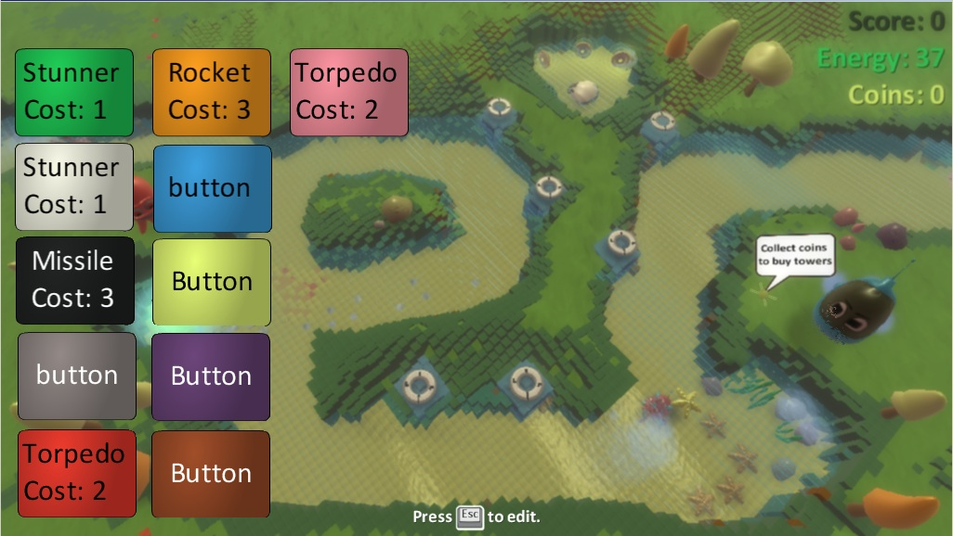If the player sets up more buttons than can fit in a single row, they automatically start a new row.

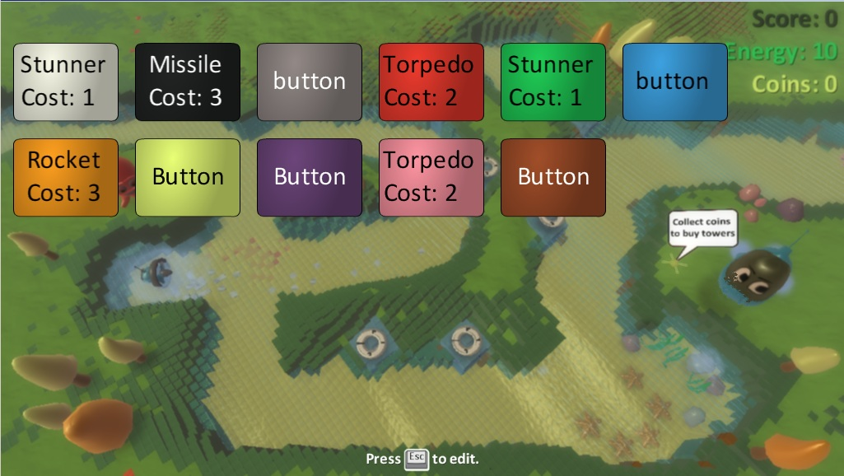Below is a mockup of all buttons on in both configurations.

NOTE #1: We will have to find a solution for buttons overlapping scores, possibly by decreasing the number of buttons across the top, although that would mean a third row if the player activated all buttons. Similarly, we’ll have to watch out for players turning on left side buttons as well as using the virtual joystick to avoid potential overlap. In most cases overlap is likely not an issue, since most Kodu projects will not turn on more than 3-4 scores or buttons, but we should still solve the edge cases.

NOTE #2: The Tower Defense levels were designed for Top or left side buttons. We would have to reconfigure the levels if we move the buttons anywhere else.

NOTE #3: Button position is also dependent on resolution and gets more crowded as resolution drops.